Interim report:

Overview
For the project so far I have decided to follow my alternative variation project idea, specified at the end of my project spec. I am using the paperprograms platform, so as to have the computer vision side of things and general interaction model setup, with which to explore the cognitive and social benefits of this interface. The new form my project will now take is through a socially experimental art work. The paper-programs as well as a keyboard or mouse will act as the interface. The aim of the interactive artwork will be to explore shareable computing. There is also this interesting github issue which includes an interesting discussion about DynamicLand’s (one inspiration for this project) relationship to open-source and their own model.
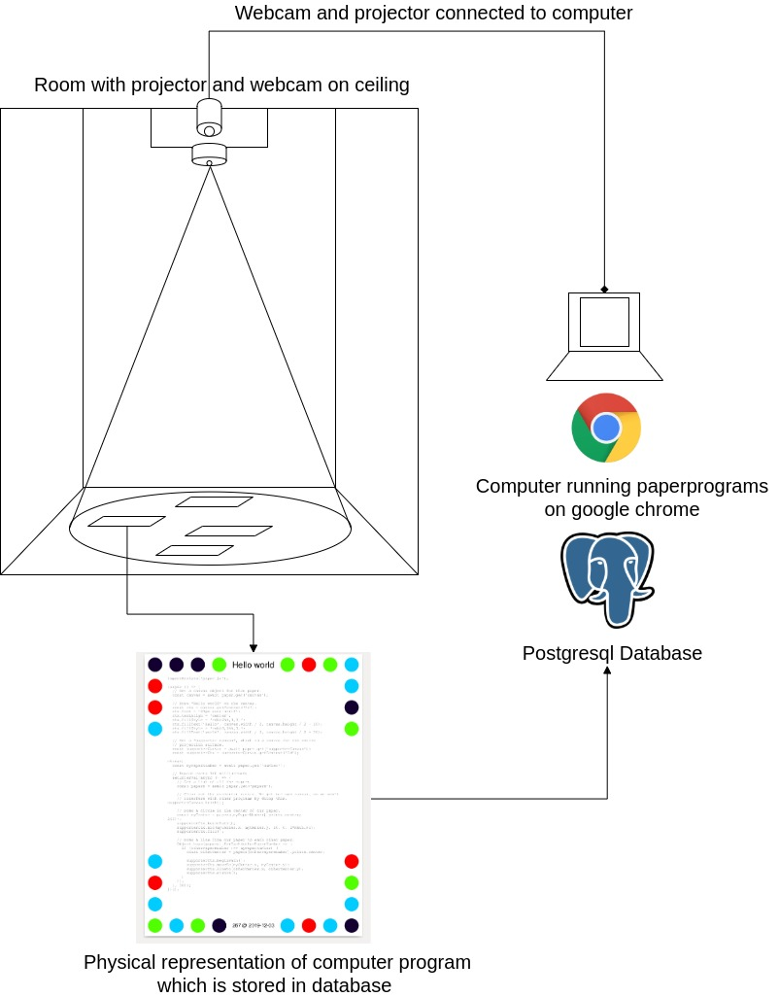
Setup diagram:
It highlights the nature of DynamicLand’s own physical source code model and their research interests. My project gives credit to their model and vision but would to explore other aspects of it as well as using the model in an arts context; such as stated above. The open sourcing of an element of DL (in paperprograms) which has made the model accessible to me.

Summary of work to date
By using a pre-built CV-based computing environment I have taken a shortcut in terms of my initial milestones (which were to implement a blob and colour tracking system and an interaction model). Instead I have increased focus on the design of the Interaction system and the theoretical surrounds in which to house the experimental game / interactive artwork.
- I looked at computer vision implementation and a model for putting together my own interactive feedback system but decided on paperprograms as the base software system.
- Ran some tests of paperprograms just with my laptop and built-in webcam. This was to check the basic mechanisms worked well. I have not yet had it setup with an external webcam and projector. I assume it will work similarly well if not more responsive with a higher resolution camera and a flat surface which the paper-programs will rest on.
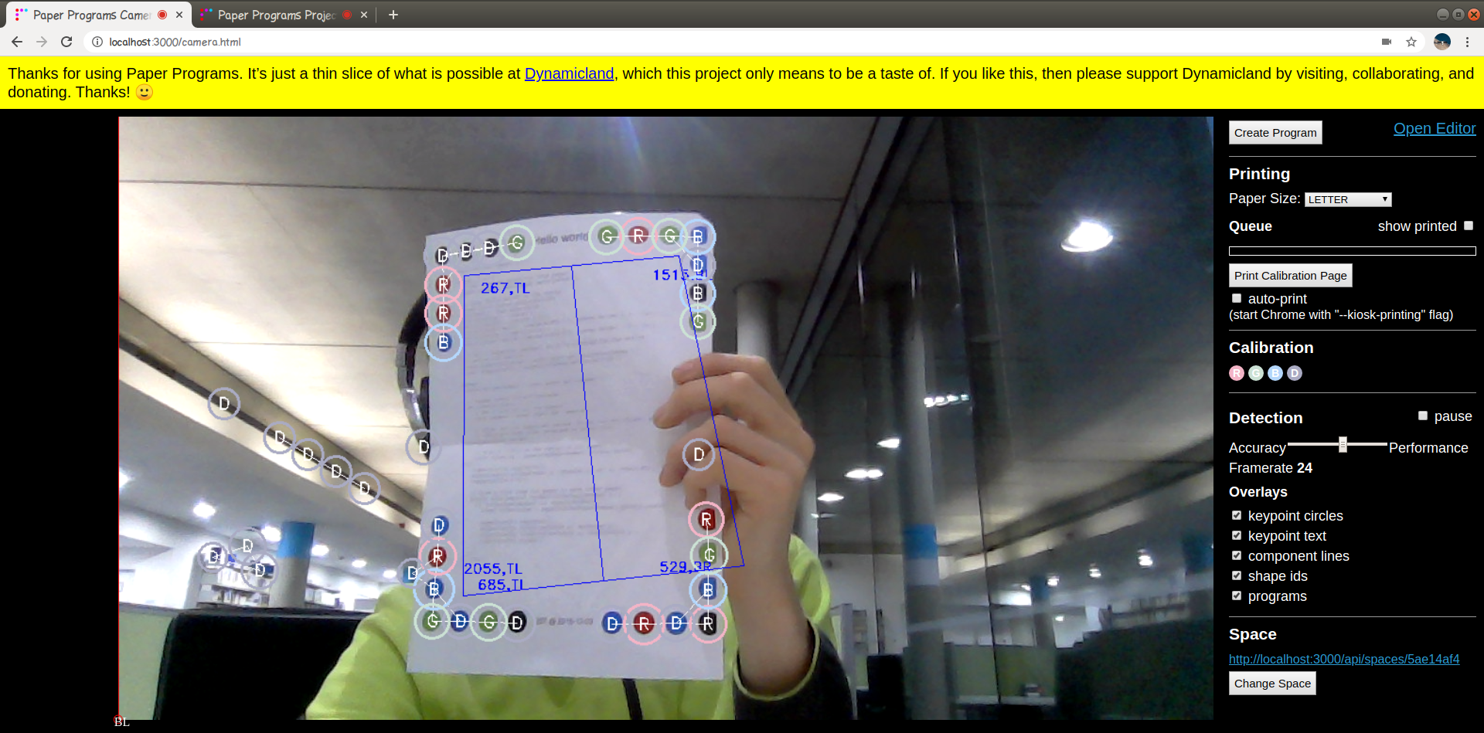
- I have aquired supplies for home setup. This includes the camera, and ceiling attachment, projector is on its way. This will be my permanent installation where I can test developments. I also plan to take it elsewhere and playtest it when first digital prototype is created.
- I have been reading through the paperprograms code to see how things are setup. This has included looking at the source code and API.
  - https://github.com/janpaul123/paperprograms/pull/28 This pull request also has a 3-4 times increase in frame rate making the system much more responsive. I have checked it out on my install and it works well.

Evaluation

Milestones have been changed and so are up to date; the original proposal had a different scope and those milestones were not met.This has been due to changing project ideas. Implementation is about to begin, so far the idea has been solidifying and I have been carrying out tests with the software. I’m also waiting on supplies so as to set up my home installation.
The project will now take the form of an artwork; a social experiment via an interactive installation and will explore shareable interfaces and interactive visualisation. The project’s evolution to an art-driven piece has changed the theoretical direction; consideration of the audience has changed. It won’t be so much a tool to be used as an experience to be had. This applies to the immediate context of the project, however it could change as the project evolves outside the scope of this assessment.
The revised outcomes are achievable in this project scope, although consideration is needed for the final presentation. Whether to have a permanent setup or just to document during this project.

Revised project plan
So using paperprograms I will do some initial prototyping in the form of simple visualisation strategies and ways of interacting with these. Prototyping will take place in two categories; physical prototyping and writing some initial code in paperprograms. When I have the installation setup these will merge, though physical prototyping will still be an important part of the process as it will allow some further ideation for the outcome.
With the work I have these theoretical aims: and questions:
- What are the cogntive benefits of this kind of interaction model?
- What are some limitations of shareable interfaces like this?
- Dynamic interaction, how can an interface where haptic interaction is involved augment user experience, particulary perception and thought?
Revised milestones:
- January to Feburary
  - Finalise design of HCI aspect through physical and digital prototyping
  - Beginning prototyping physical:
    - Experimental game idea
    - Social interaction through computing
    - Explorable visualiser; scale-aware
  - Define and create a playtest ready prototype
- Feburary to March
  - Implement and play test first game experiment, this will be a simple interaction design example or game which makes use of the interactive medium the setup presents.
  - Iterate. Including a user testing installation in Goldsmiths or elsewhere. Could be through Themselves event (?) or day in university room etc. Initially I will playtest on my home installation and this can be done earlier.
- March to april
  - Further iteration. Relate back to theoretical basis.
  - Further playtesting. Investigate how the install could be publically displayed.
  - Aim to have final work ready by the end of April. Ready for write up in May.

5. Demo Video
6. Gitlab repo

